Solutions of Quiz-3 problems
QUIZ-3a

Q: A ladder network has a voltage gain of

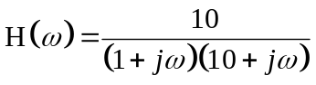

Sketch the Bode plots for the gain.

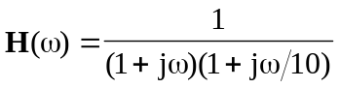

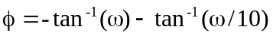

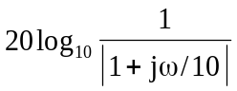
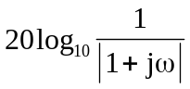
The magnitude and phase plots are shown below.
H_{dB}
0.1
-40
⬥
100
1
10
-20
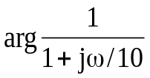

-135
-45
⬥
100
1
10
0.1
-180
-90

QUIZ-3b
Q: Sketch the Bode plots for

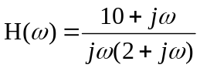
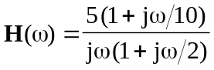

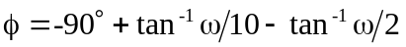

The magnitude and phase plots are shown below.
H_{dB}
-20
20
⬥
100
1
10
0.1
-40
40
34
14


-45
45
⬥
100
1
10
0.1
-90
90

QUIZ-3C
Q: The Bode magnitude plot of H(ω) is shown in Fig. 14.72. Find H(ω).

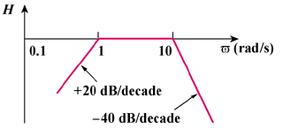

A zero of slope 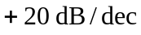 at the origin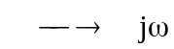

A pole of slope 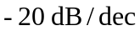 at 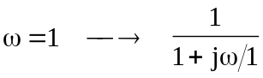

A pole of slope 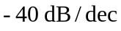 at 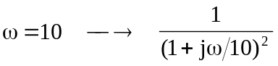

Hence,
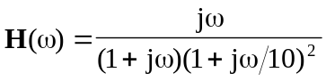

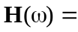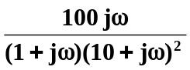

QUIZ-3d
Q: For the circuit in Fig. 14.74, find the frequency ω for which v(t) and i(t) are in phase.

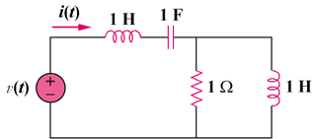

Z
j
1
j
1/j

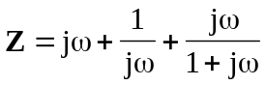

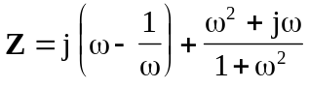

Since 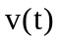 and 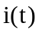 are in phase,
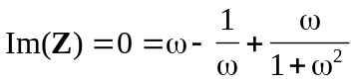

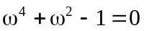

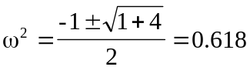

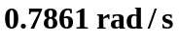

QUIZ-3e
Q: Design an RL lowpass filter that uses a 40-mH coil and has a cutoff frequency of 5 kHz.

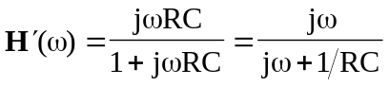 (from Eq. 14.52)

This has a unity passband gain, i.e. 
